Skip to content
https://openai.com/index/chatgpt/ python code using adfuller
ChatGPT said:
Here’s a clean Python example using statsmodels.tsa.stattools.adfuller() for stationarity testing, based on common patterns and official docs Reddit+15StatsModels+15programcreek.com+15:
import pandas as pd import numpy as np import matplotlib.pyplot as plt from statsmodels.tsa.stattools import adfuller def adf_test(series, autolag='AIC', regression='c'): """ Performs the Augmented Dickey-Fuller test. series: 1D iterable (list, np.array, pd.Series) autolag: 'AIC', 'BIC', 't-stat' or None regression: 'c' (constant), 'ct' (with trend), 'ctt' or 'nc' (no constant) """ result = adfuller(series, autolag=autolag, regression=regression) output = pd.Series(result[0:4], index=[ 'Test Statistic', 'p-value', '#Lags Used', 'Number of Observations Used' ]) for key, val in result[4].items(): output[f'Critical Value ({key})'] = val return output # Example: AirPassengers dataset (monthly totals of international airline passengers) df = pd.read_csv('AirPassengers.csv', index_col=0, parse_dates=True) ts = df.iloc[:, 0].astype(float) print("Original series ADF test:") print(adf_test(ts)) # If non-stationary (e.g., unit-root present, p-value > 0.05), # apply transformations: ts_log = np.log(ts) ts_log_diff = ts_log.diff().dropna() print("\nAfter log transform + first difference:") print(adf_test(ts_log_diff))

🔍 What this code does
- Imports adfuller from statsmodels programcreek.com+3GeeksforGeeks+3Reddit+3Stack Overflow+1Stack Overflow+1dkedar7.github.io+8pytutorial.com+8Reddit+8Reddit+5MachineLearningMastery.com+5Reddit+5Reddit.
- Defines a helper adf_test to run the test and format results.
- Reads a time series into a 1D numeric array (required by adfuller) Stack OverflowStack Overflow.
- Prints the test before and after commonly used transformations:
  - Log transform (to stabilize variance)
  - First differencing (to remove trend / unit root)

🧠 Interpreting the results
- The null hypothesis is that a unit root (non-stationarity) exists.
- Rejecting it (i.e., test statistic < critical value or p-value < 0.05) indicates stationarity Stack Overflow+13StatsModels+13StatsModels+13Stack Overflow+13pytutorial.com+13Reddit+13Reddit.
- A statistic above critical values or a high p-value means non-stationary—suggesting differencing, detrending, or transformations may be necessary.

Tips from the community 🗣
Reddit and StackOverflow users note:
“tr must be a 1d array … you have a DataFrame. You should do series = df.iloc[:,0].values” Stack Overflow.
Also, transforming like np.log and .diff() is common and effective in practice dkedar7.github.io.

✅ Summary
- Use adfuller() on a 1D numeric series.
- Check the test statistic, p-value, and critical values.
- Apply log transform + first differencing if non-stationary.
- For model fitting (like ARIMA), confirm stationarity before proceeding.
Let me know if you'd like to automate this testing over multiple columns, tune lag selection, or plot ADF results!
You said:
with example
ChatGPT said:
Here’s a detailed Python example using adfuller() from statsmodels, including a real dataset and step-by-step outputs:
import numpy as np import pandas as pd import matplotlib.pyplot as plt from statsmodels.tsa.stattools import adfuller # 1. Load a real-world time series (airline passengers) url = "https://raw.githubusercontent.com/jbrownlee/Datasets/master/airline-passengers.csv" data = pd.read_csv(url, parse_dates=['Month'], index_col='Month') ts = data['Passengers'].astype(float) # Optional: visualize ts.plot(title='Monthly Airline Passengers (1949–1960)') plt.show() # 2. Define helper to run ADF test def adf_test(series, autolag='AIC', regression='c'): result = adfuller(series, autolag=autolag, regression=regression) output = pd.Series(result[0:4], index=[ 'Test Statistic', 'p-value', '#Lags Used', 'Observations' ]) for key, val in result[4].items(): output[f'Critical Value ({key})'] = val return output # 3. Run ADF on original series print("=== Original Series ===") print(adf_test(ts)) # 4. Transform: log and first difference (remove trend/variance issues) ts_log = np.log(ts) ts_diff = ts_log.diff().dropna() print("\n=== Log-diff Transformed Series ===") print(adf_test(ts_diff)) # 5. Interpretation: # If original series has p-value > 0.05 and larger test statistic than critical, # it’s non-stationary. After log/diff, p-value should drop below 0.05 and # statistic should fall under critical — meaning stationarity achieved.

📌 What Happens When You Run It
- Original series: you'll likely see p-value > 0.05 and a test statistic higher than critical values — indicating non-stationarity Reddit+15GeeksforGeeks+15PyTutorial+15Analytics VidhyaReintech+5GeeksforGeeks+5Analytics Vidhya+5.
- After log + differencing: you'll see p-value < 0.05 and test statistic below critical values — confirming stationarity ReintechAnalytics Vidhya.

✅ Real-World Example from Web
On a10.csv, a test failed with:
# p-value = 1.0, ADF stat = +3.145 → strongly non-stationary
TutorialsPoint+1Reddit+1

Quick Summary of Steps
Step | Action | Why
1 | Visualize the series | Spot trend/variance
2 | Run ADF test (regression='c' by default) | Check for unit root
3 | p-value > 0.05 ⇒ non-stationary | p more than 0.05 fails to reject null Reddit+5Reddit+5Reddit+5Analytics Vidhya+13GeeksforGeeks+13statsmodels.org+13
4 | Apply transforms: log, diff() (maybe seasonal differencing) | Remove trend/variance
5 | Re-run ADF | Expect p-value < 0.05, stat < critical ⇒ stationary

🧠 Community Advice
Reddit discussions highlight pitfalls like misinterpreting p-values or needing trend adjustments:
“Your p-value was 3.08 → misreading; actually it was 3e-10!” Reddit

Next Steps
Once you confirm stationarity, you can confidently proceed to modeling — such as ARIMA, SARIMAX, or other pipeline steps.
Let me know if you’d like code to iterate this test across multiple columns, handle seasonal differencing automatically, or plot the differenced series!
You said:
appending the data to the series pd.series
ChatGPT said:
Here’s how you can append new data to a pd.Series and then run the ADF test:

✅ 1. Appending to a Series
Option A: Using pd.concat() (current best practice)
import pandas as pd # Original series s = pd.Series([1.0, 2.0, 3.0], index=pd.to_datetime(['2025-07-20','2025-07-21','2025-07-22'])) # New data as a one-element series new = pd.Series([2.5], index=pd.to_datetime(['2025-07-23'])) # Append via concat s = pd.concat([s, new])
This method works with single values, lists, or other series Reddit+15Sling Academy+15StatsModels+15.

Option B: Direct assignment by position
s[len(s)] = 2.8
Pandas will auto-extend the series with the next integer-based index Finxter Blog.

⚠️ Deprecated: .append()
You can still do:
s = s.append(pd.Series([3.1], index=[pd.Timestamp('2025-07-24')]))
But it’s deprecated and emits a warning. It works similarly Reddit.

🧪 2. Full Example with ADF Test
import numpy as np from statsmodels.tsa.stattools import adfuller # Step 1: initial series s = pd.Series([10, 11, 12, 13], index=pd.to_datetime(['2025-07-20','2025-07-21','2025-07-22','2025-07-23'])) # Step 2: append new observations new_data = pd.Series([14, 15], index=pd.to_datetime(['2025-07-24','2025-07-25'])) s = pd.concat([s, new_data]) # Step 3: optional transform (log + diff) s_log = np.log(s) s_diff = s_log.diff().dropna() # Step 4: run ADF test result = adfuller(s_diff, autolag='AIC', regression='c') print("ADF Statistic:", result[0]) print("p-value:", result[1]) for key, val in result[4].items(): print(f"Critical Value ({key}): {val}")

📝 Why use pd.concat?
Appending one-by-one is inefficient: each operation copies the data and index Reddit+10Docs4Dev+10PythonForBeginners.com+10RedditReddit+4Stack Overflow+4Finxter Blog+4. Better to build or concatenate in bulk.

✅ TL;DR
Task | Method
Append new values | pd.concat([old_series, new_series])
Single value assignment | s[len(s)] = value
Deprecated method | s.append(...) ❌
Efficient bulk updates | Collect values then pd.concat at end
Let me know if you'd like to append data in a loop, or update multiple time-series columns at once!
You said:
convert data frame data to series with an example
ChatGPT said:
Here are several clear ways to convert a pandas DataFrame into a Series, depending on what you're aiming to extract:

1. Extract a single column 📄
Treating a column as a Series is the most common case:
import pandas as pd df = pd.DataFrame({'A': [1, 2, 3], 'B': [4, 5, 6]}) series_a = df['A'] # or df.A if 'A' is a valid identifier print(type(series_a)) # → <class 'pandas.core.series.Series'>
This selects column 'A' as a Series Reddit+15iDiTect+15Finxter Blog+15.

2. Convert a single-column DataFrame using .squeeze()
Ideal when your DataFrame has only one column (or one row), and you want to "collapse" its dimensions:
df_single = pd.DataFrame({'C': [7, 8, 9]}) series_c = df_single.squeeze() print(type(series_c)) # → Series
Works along either axis—rows or columns Sling Academy.

3. Convert a single row to a Series using .iloc + .squeeze()
When you need data from a particular row:
df = pd.DataFrame({'A': [1], 'B': [2], 'C': [3]}) series_row0 = df.iloc[0].squeeze() print(series_row0) # A 1 # B 2 # C 3
Each DataFrame row becomes a Series with column names as the index Reddit.

4. Stack the DataFrame to combine columns into a single Series
If you want to combine multiple columns vertically:
df = pd.DataFrame({'A': [1,2,3], 'B': [4,5,6]}) stacked = df.stack().reset_index(drop=True) print(stacked) # 0 1 # 1 2 # 2 3 # 3 4 # 4 5 # 5 6
.stack() turns a wide DataFrame into a tall Series Reddit+15iDiTect+15Reddit+15.

✅ Quick Summary
Goal | Code Example
Single column → Series | s = df['col'] or df.col
Single-column DataFrame → Series | s = df.squeeze()
Specific row → Series | s = df.iloc[row].squeeze()
**All columns merged →
series** | s = df.stack().reset_index(drop=True) |
Let me know if you'd like help with index handling, multiple columns, or preserving row labels!
You said:
value error: setting an array element with a sequence
ChatGPT said:
The error message ValueError: setting an array element with a sequence typically occurs in Python when you're trying to assign a list, tuple, or another sequence to a position in a NumPy array that expects a single scalar value. This often happens when:
- The array is of a fixed data type (e.g., int or float), and you're trying to assign a sequence (like a list or tuple) to an element.
- You're trying to assign a sequence to an individual element of the array, which expects a single value.

🛠️ Common Causes and Solutions
1. Assigning a Sequence to a Single Element
import numpy as np arr = np.zeros(5) arr[0] = [1, 2] # This will raise the ValueError
Solution: Ensure that you're assigning a single value to each element:
arr[0] = 1 # Correct
If you intend to assign a sequence to an entire row or column, make sure the dimensions match:
arr[0:2] = [1, 2] # Correct: assigning to a slice
2. Creating a Jagged Array
arr = np.array([[1, 2], [3, 4, 5]]) # This will raise the ValueError
Solution: Ensure that all inner lists have the same length:
arr = np.array([[1, 2], [3, 4]]) # Correct
Alternatively, if you need to store sequences of different lengths, create an array with dtype=object:
arr = np.array([[1, 2], [3, 4, 5]], dtype=object) # Correct
3. Mismatched Data Types
arr = np.array([1.0, 2.0, 3.0]) arr[0] = "a" # This will raise the ValueError
Solution: Ensure that the data types are compatible:
arr = np.array([1.0, 2.0, 3.0], dtype=object) arr[0] = "a" # Correct

🧪 Example: Converting a DataFrame Column to a Series
If you're working with a pandas DataFrame and want to convert a column to a Series:
import pandas as pd df = pd.DataFrame({'A': [1, 2, 3], 'B': [4, 5, 6]}) series_a = df['A']
This will give you a pandas Series:
0 1
1 2
2 3
Name: A, dtype: int64
If you encounter the ValueError while performing operations on the Series, ensure that:
- You're not assigning a sequence to a single element.
- The dimensions of the data you're working with match the expected dimensions.

✅ Summary
- Assigning a sequence to a single element: Ensure you're assigning a scalar value to each element.
- Jagged arrays: Ensure all inner lists have the same length or use dtype=object if necessary.
- Mismatched data types: Ensure that the data types are compatible or use dtype=object to allow for mixed types.
If you can provide the specific code snippet where you're encountering this error, I can offer more tailored assistance.
You said:
remove inf or nans from a series
ChatGPT said:
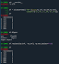
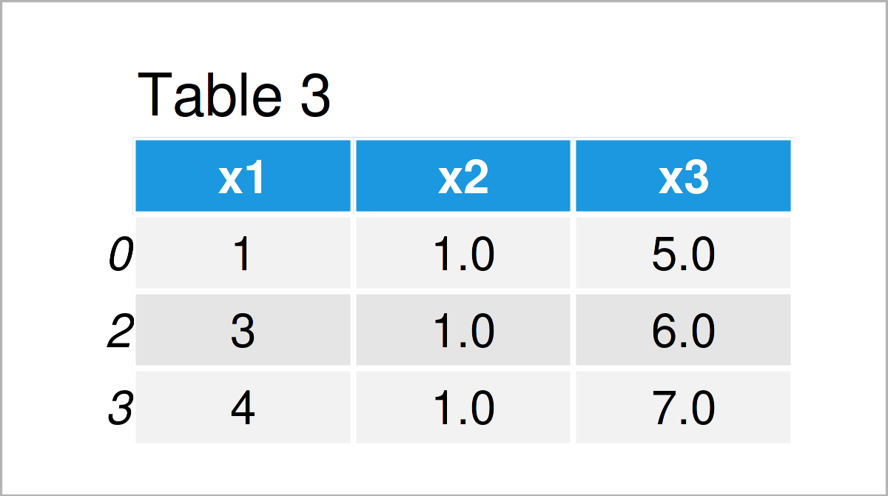
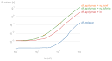

To remove NaN and infinite (Inf, -Inf) values from a pandas Series, you can use the following methods:

✅ 1. Replace Inf with NaN and Drop All NaN Values
This approach ensures that both positive and negative infinity values are treated as missing data and removed:
import pandas as pd import numpy as np # Sample Series with NaN and Inf values s = pd.Series([1, np.nan, np.inf, -np.inf, 2, 3]) # Replace Inf values with NaN and drop all NaN values s_cleaned = s.replace([np.inf, -np.inf], np.nan).dropna() print(s_cleaned)
Output:
0 1.0
4 2.0
5 3.0
dtype: float64
This method is effective for cleaning data before analysis or visualization.

✅ 2. Use Boolean Indexing to Keep Only Finite Values
If you prefer not to modify the original Series, you can filter out non-finite values:
import pandas as pd import numpy as np # Sample Series with NaN and Inf values s = pd.Series([1, np.nan, np.inf, -np.inf, 2, 3]) # Keep only finite values s_cleaned = s[np.isfinite(s)] print(s_cleaned)
Output:
0 1.0
4 2.0
5 3.0
dtype: float64
This method is useful when you want to retain the original Series and create a cleaned version.

✅ 3. Use dropna() After Replacing Inf Values
Alternatively, you can replace Inf values with NaN and then drop all NaN values:
import pandas as pd import numpy as np # Sample Series with NaN and Inf values s = pd.Series([1, np.nan, np.inf, -np.inf, 2, 3]) # Replace Inf values with NaN s = s.replace([np.inf, -np.inf], np.nan) # Drop all NaN values s_cleaned = s.dropna() print(s_cleaned)
Output:
0 1.0
4 2.0
5 3.0
dtype: float64
This method is straightforward and commonly used in data preprocessing.

⚠️ Note on Deprecation
The mode.use_inf_as_na option, which allowed treating Inf values as NaN, has been deprecated and will be removed in pandas 3.0. Therefore, it's recommended to use the methods above for handling Inf and NaN values .

If you need further assistance with handling NaN and Inf values in pandas Series or DataFrames, feel free to ask!
You said:
in python code
ChatGPT said:
To remove NaN and infinite (Inf, -Inf) values from a pandas Series in Python, you can use the following methods:

✅ 1. Replace Inf with NaN and Drop All NaN Values
import pandas as pd import numpy as np # Sample Series with NaN and Inf values s = pd.Series([1, np.nan, np.inf, -np.inf, 2, 3]) # Replace Inf values with NaN and drop all NaN values s_cleaned = s.replace([np.inf, -np.inf], np.nan).dropna() print(s_cleaned)
Output:
0 1.0
4 2.0
5 3.0
dtype: float64
This method replaces both positive and negative infinity values with NaN and then removes all NaN values from the Series.

✅ 2. Use Boolean Indexing to Keep Only Finite Values
import pandas as pd import numpy as np # Sample Series with NaN and Inf values s = pd.Series([1, np.nan, np.inf, -np.inf, 2, 3]) # Keep only finite values s_cleaned = s[np.isfinite(s)] print(s_cleaned)
Output:
0 1.0
4 2.0
5 3.0
dtype: float64
This method filters out NaN and infinite values by checking for finite values using np.isfinite().

⚠️ Note on Deprecation
The mode.use_inf_as_na option, which allowed treating Inf values as NaN, has been deprecated and will be removed in pandas 3.0. Therefore, it's recommended to use the methods above for handling Inf and NaN values.

If you need further assistance with handling NaN and Inf values in pandas Series or DataFrames, feel free to ask!
You said:
create a dataframe only with two columns from a dataframe with multiple columns in python with example
ChatGPT said:
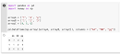

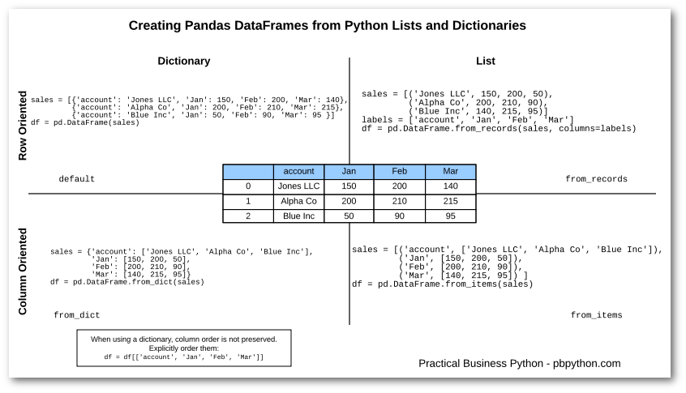
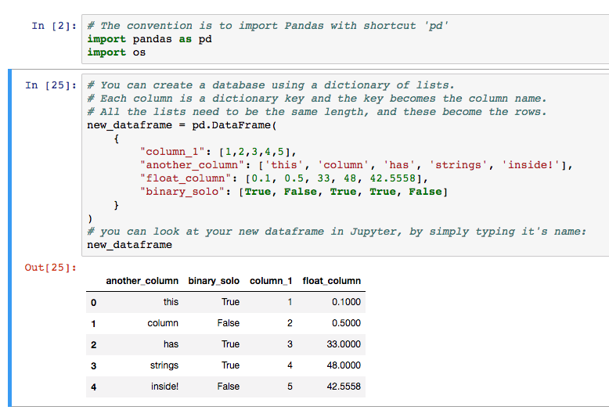
To create a new pandas DataFrame containing only two specific columns from an existing DataFrame, you can use several straightforward methods. Here's how to do it:

✅ Method 1: Using Column Names
If you know the names of the columns you want to select, you can pass them as a list to the DataFrame:
import pandas as pd # Sample DataFrame df = pd.DataFrame({ 'Name': ['Alice', 'Bob', 'Charlie'], 'Age': [25, 30, 35], 'City': ['New York', 'Los Angeles', 'Chicago'] }) # Select 'Name' and 'City' columns df_selected = df[['Name', 'City']] print(df_selected)
Output:
Name City
0 Alice New York
1 Bob Los Angeles
2 Charlie Chicago

✅ Method 2: Using .iloc[] for Index-Based Selection
If you prefer to select columns based on their index positions, you can use .iloc[]. For example, to select the first and third columns:
df_selected = df.iloc[:, [0, 2]] print(df_selected)
Output:
Name City
0 Alice New York
1 Bob Los Angeles
2 Charlie Chicago

✅ Method 3: Using .loc[] with Column Labels
Alternatively, you can use .loc[] to select columns by their labels:
df_selected = df.loc[:, ['Name', 'City']] print(df_selected)
Output:
Name City
0 Alice New York
1 Bob Los Angeles
2 Charlie Chicago

✅ Method 4: Using .filter() for Pattern Matching
If you want to select columns based on a pattern in their names, you can use .filter():
df_selected = df.filter(items=['Name', 'City']) print(df_selected)
Output:
Name City
0 Alice New York
1 Bob Los Angeles
2 Charlie Chicago

✅ Method 5: Using .drop() to Exclude Unwanted Columns
If you prefer to drop the columns you don't want, you can use .drop():
df_selected = df.drop(columns=['Age']) print(df_selected)
Output:
Name City
0 Alice New York
1 Bob Los Angeles
2 Charlie Chicago

⚠️ Important Note
- Method 1: Use this when you know the exact column names.
- Method 2: Useful when selecting columns by their index positions.
- Method 3: Similar to Method 1 but using .loc[].
- Method 4: Ideal for selecting columns based on name patterns.
- Method 5: Best when you want to exclude specific columns.
Choose the method that best fits your needs based on how you want to select the columns.
If you need further assistance or have specific requirements, feel free to ask!
You said:
python code to derive a dataframe from another dataframe with few columns
ChatGPT said:
To create a new pandas DataFrame by selecting specific columns from an existing DataFrame, you can use several straightforward methods. Here's how to do it:

✅ Method 1: Using Square Brackets with Column Names
If you know the names of the columns you want to select, you can pass them as a list to the DataFrame:
import pandas as pd # Sample DataFrame df = pd.DataFrame({ 'Name': ['Alice', 'Bob', 'Charlie'], 'Age': [25, 30, 35], 'City': ['New York', 'Los Angeles', 'Chicago'] }) # Select 'Name' and 'City' columns df_selected = df[['Name', 'City']] print(df_selected)
Output:
Name City
0 Alice New York
1 Bob Los Angeles
2 Charlie Chicago
This method is effective when you know the exact column names you want to include in the new DataFrame.

✅ Method 2: Using .loc[] for Label-Based Indexing
Alternatively, you can use .loc[] to select specific columns:
df_selected = df.loc[:, ['Name', 'City']] print(df_selected)
Output:
Name City
0 Alice New York
1 Bob Los Angeles
2 Charlie Chicago
This approach is useful when you want to select columns by their labels.

✅ Method 3: Using .filter() for Pattern Matching
If you want to select columns based on a pattern in their names, you can use .filter():
df_selected = df.filter(items=['Name', 'City']) print(df_selected)
Output:
Name City
0 Alice New York
1 Bob Los Angeles
2 Charlie Chicago
This method is ideal for selecting columns that match a specific pattern.

✅ Method 4: Using .drop() to Exclude Unwanted Columns
Alternatively, you can drop the columns you don't want to include:
df_selected = df.drop(columns=['Age']) print(df_selected)
Output:
Name City
0 Alice New York
1 Bob Los Angeles
2 Charlie Chicago
This approach is useful when you want to exclude specific columns from the new DataFrame.

✅ Method 5: Using .assign() to Create a New DataFrame
You can also use .assign() to create a new DataFrame with selected columns:
df_selected = pd.DataFrame().assign(Name=df['Name'], City=df['City']) print(df_selected)
Output:
Name City
0 Alice New York
1 Bob Los Angeles
2 Charlie Chicago
This method allows you to create a new DataFrame and assign selected columns to it.

⚠️ Important Notes
- Creating a Copy: When selecting columns, it's often a good practice to create a copy of the DataFrame to avoid modifying the original DataFrame unintentionally. You can do this by chaining .copy() to any of the above methods:
df_selected = df[['Name', 'City']].copy()
- Performance Considerations: The methods provided are efficient for selecting specific columns. However, if you're working with a very large DataFrame and need to select a large number of columns, consider using .filter() or .loc[] for better performance.

If you need further assistance or have specific requirements, feel free to ask!
You said:
exog contains inf or nans
ChatGPT said:
If you're encountering the error MissingDataError: exog contains inf or nans in a statsmodels model (such as OLS or ARIMA), it indicates that your explanatory variables (exog) contain NaN (Not a Number) or Inf (infinite) values, which are not handled by statsmodels. Even if your checks suggest otherwise, these values might still be present due to data type issues or hidden missing values.

✅ Steps to Resolve the Error
1. Convert Columns to Compatible Data Types
Statsmodels can encounter issues with unsigned integer types like UInt32. Converting all columns to float64 or int64 can resolve this:Stack Overflow
df = df.astype('float64')
This conversion ensures that all columns are of a type compatible with statsmodels. Stack Overflow
2. Check for Hidden Missing Values
Even if .isna().sum() returns 0, there might still be missing values due to data type issues. Use the following checks:Stack Overflow
import numpy as np # Check for NaN values print(df.isna().sum()) # Check for infinite values print(np.isinf(df).sum())
These checks will help identify any hidden missing or infinite values.
3. Remove or Replace Missing Values
If missing values are found, you can either remove or replace them:
- Remove rows with missing values:
df_cleaned = df.dropna()
- Replace missing values with a placeholder (e.g., 0):
df_filled = df.fillna(0)
Choose the method that best fits your analysis requirements.
4. Ensure No Constant Columns
Statsmodels requires that explanatory variables (exog) have variability. If any column has constant values (e.g., all zeros), it can cause issues:
import numpy as np # Check for constant columns constant_columns = df.columns[df.nunique() == 1] print("Constant columns:", constant_columns)
Remove or modify these columns as needed:GitHub+2Stack Overflow+2GitHub+2
df_cleaned = df.drop(columns=constant_columns)

🛠️ Example: Handling Missing or Infinite Values
Here's a complete example that addresses these issues:
import pandas as pd import numpy as np import statsmodels.api as sm # Sample DataFrame df = pd.DataFrame({ 'A': [1, 2, np.nan, 4], 'B': [5, np.inf, 7, 8], 'C': [9, 10, 11, 12] }) # Convert all columns to float64 df = df.astype('float64') # Check for missing or infinite values if df.isna().sum().sum() > 0 or np.isinf(df).sum().sum() > 0: print("Data contains missing or infinite values.") # Handle missing/infinite values df_cleaned = df.dropna() # Alternatively, replace missing/infinite values # df_cleaned = df.replace([np.inf, -np.inf], np.nan).fillna(0) else: df_cleaned = df # Add constant term for OLS X = sm.add_constant(df_cleaned) # Sample dependent variable y = pd.Series([1, 2, 3, 4]) # Fit OLS model model = sm.OLS(y, X) results = model.fit() print(results.summary())
This script ensures that your data is clean and compatible with statsmodels, allowing for successful model fitting.

If you need further assistance or have specific questions about your dataset, feel free to ask!
You said:
convert float to int
ChatGPT said:
To convert a floating-point number to an integer in Python, you can use several methods, each serving different purposes. Here's a breakdown:

✅ 1. Using int(): Truncation
The int() function truncates the decimal part and returns the integer part of the float.Stack Overflow+6Codedamn+6GeeksforGeeks+6
n = 9.7 n_int = int(n) print(n_int) # Output: 9
Note: This method truncates towards zero, so for negative numbers, it removes the fractional part without rounding.Python Guides

✅ 2. Using round(): Rounding to Nearest Integer
The round() function rounds the float to the nearest integer. If the decimal part is exactly 0.5, Python rounds to the nearest even number (banker's rounding).Python Guides
n = 9.5 n_rounded = round(n) print(n_rounded) # Output: 10

✅ 3. Using math.floor(): Rounding Down
The math.floor() function returns the largest integer less than or equal to the float, effectively rounding down.Flexiple+1Python Guides+1
import math n = 9.7 n_floor = math.floor(n) print(n_floor) # Output: 9

✅ 4. Using math.ceil(): Rounding Up
The math.ceil() function returns the smallest integer greater than or equal to the float, effectively rounding up.Python Guides
import math n = 9.3 n_ceil = math.ceil(n) print(n_ceil) # Output: 10

✅ 5. Using // Operator: Integer Division
The // operator performs integer (floor) division, discarding the remainder.
n = 9.7 n_int_div = n // 1 print(n_int_div) # Output: 9.0
Note: This returns a float, so you may need to convert it to an integer explicitly.

✅ 6. Using .astype(int) with NumPy Arrays
If you're working with NumPy arrays, you can convert all float elements to integers using the .astype(int) method.Python Guides
import numpy as np arr = np.array([1.5, 2.7, 3.9]) arr_int = arr.astype(int) print(arr_int) # Output: [1 2 3]

⚠️ Important Considerations
- Data Loss: Converting a float to an integer removes the decimal part, leading to potential data loss.Python Tutorial+7Codedamn+7Akamai+7
- Negative Numbers: Methods like int() and // truncate towards zero, which may not be suitable for all applications.Python Guides
- Precision Issues: Floating-point numbers may have precision issues due to their representation in memory.GeeksforGeeks

If you have a specific scenario or dataset in mind, feel free to provide more details, and I can offer tailored advice!

Attach
Search
Voice

ChatGPT can make mistakes. Check important info. See Cookie Preferences.

